What is Roles? Are directory structure way to organize your configuration per project.

Group related tasks to gather.

Under roles you create role for each category of tasks and each role must have folders with predefined names on ansible like tasks ,handlers and playbook on each one must have one name of three -🡪

1. main.yaml
2. main.yml
3. main

ansible will search for these file if it not found you’ll be in trouble.

1. project_play.yml -> is main playbook that will be run let’s explore it , this playbook used to import other playbook

import_playbook: filename

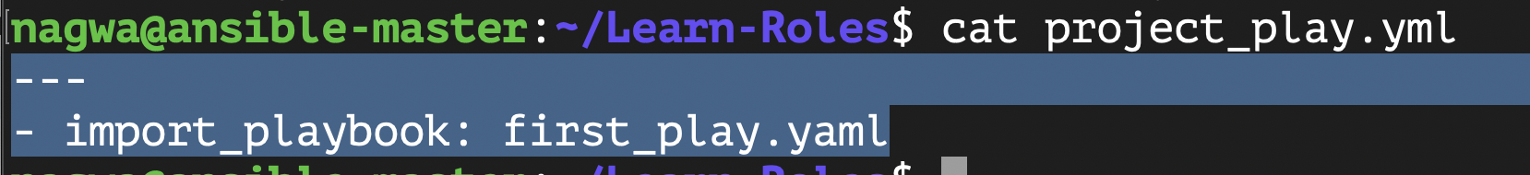

1. let’s explore first_play.yml

this playbook used to identify hosts that this tasks will run on and identify that user running tasks on slave servers will be sudo and final thing it identify roles

1. explore inventory

1. explore ansible.cfg -🡪 this file contain default configuration for ansible , remote_user that will do ssh on slave and execute tasks ,private key will be used,..

Now its time to dig into roles

Now see configuration of roley

